**Which name do you prefer for the following method?**

1.

Please read through the following code snippet where the original method name is marked by "\*\*\*". If necessary, you can refer to the enclosing class of the method at [this link](https://r.wjx.com/redirect.aspx?url=https%3A%2F%2Fgithub.com%2Fjiangyanjie%2FsurveyData%2Fblob%2Fmain%2FFirstRound%2F1%2F1.java&activity=267569930" \t "_blank). Among the names provided below, please indicate your preference for the method name.

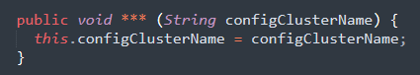 \*

|  |
| --- |
| setConfigClusterName |
| setConfigurationClusterName |

Please kindly explain why the selected option should be preferred.

\*

\_\_\_\_\_\_\_\_\_\_\_\_\_\_\_\_\_\_\_\_\_\_\_\_\_\_\_\_\_\_\_\_\_

2.

Please read through the following code snippet where the original method name is marked by "\*\*\*". If necessary, you can refer to the enclosing class of the method at [this link](https://r.wjx.com/redirect.aspx?url=https%3A%2F%2Fgithub.com%2Fjiangyanjie%2FsurveyData%2Fblob%2Fmain%2FFirstRound%2F3%2F3.java&activity=267569930" \t "_blank). Among the names provided below, please indicate your preference for the method name.

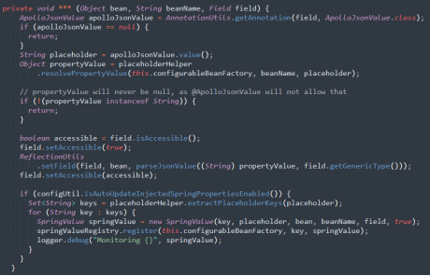 \*

|  |
| --- |
| processApolloJsonValue |
| processApolloJavaScriptObjectNotationValue |

Please kindly explain why the selected option should be preferred \*

\_\_\_\_\_\_\_\_\_\_\_\_\_\_\_\_\_\_\_\_\_\_\_\_\_\_\_\_\_\_\_\_\_

3.

Please read through the following code snippet where the original method name is marked by "\*\*\*". If necessary, you can refer to the enclosing class of the method at [this link](https://r.wjx.com/redirect.aspx?url=https%3A%2F%2Fgithub.com%2Fjiangyanjie%2FsurveyData%2Fblob%2Fmain%2FFirstRound%2F2%2F2.java&activity=267569930" \t "_blank). Among the names provided below, please indicate your preference for the method name.

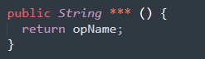 \*

|  |
| --- |
| getOpName |
| getOperationName |

Please kindly explain why the selected option should be preferred \*

\_\_\_\_\_\_\_\_\_\_\_\_\_\_\_\_\_\_\_\_\_\_\_\_\_\_\_\_\_\_\_\_\_

4.

Please read through the following code snippet where the original method name is marked by "\*\*\*". If necessary, you can refer to the enclosing class of the method at [this link](https://r.wjx.com/redirect.aspx?url=https%3A%2F%2Fgithub.com%2Fjiangyanjie%2FsurveyData%2Fblob%2Fmain%2FFirstRound%2F4%2F4.java&activity=267569930" \t "_blank). Among the names provided below, please indicate your preference for the method name.

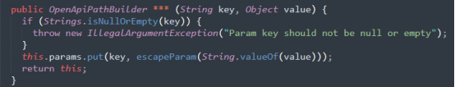

\*

|  |
| --- |
| addParam |
| addParameter |

Please kindly explain why the selected option should be preferred \*

\_\_\_\_\_\_\_\_\_\_\_\_\_\_\_\_\_\_\_\_\_\_\_\_\_\_\_\_\_\_\_\_\_

5.

Please read through the following code snippet where the original method name is marked by "\*\*\*". If necessary, you can refer to the enclosing class of the method at [this link](https://r.wjx.com/redirect.aspx?url=https%3A%2F%2Fgithub.com%2Fjiangyanjie%2FsurveyData%2Fblob%2Fmain%2FFirstRound%2F10%2F10.java&activity=267569930" \t "_blank). Among the names provided below, please indicate your preference for the method name.

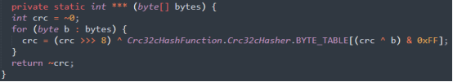 \*

|  |
| --- |
| referenceCrc |
| referenceCyclicRedundancyCheck |

Please kindly explain why the selected option should be preferred \*

\_\_\_\_\_\_\_\_\_\_\_\_\_\_\_\_\_\_\_\_\_\_\_\_\_\_\_\_\_\_\_\_\_

6.

Please read through the following code snippet where the original method name is marked by "\*\*\*". If necessary, you can refer to the enclosing class of the method at [this link](https://r.wjx.com/redirect.aspx?url=https%3A%2F%2Fgithub.com%2Fjiangyanjie%2FsurveyData%2Fblob%2Fmain%2FFirstRound%2F12%2F12.java&activity=267569930" \t "_blank). Among the names provided below, please indicate your preference for the method name.

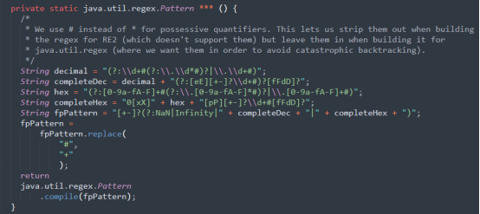

\*

|  |
| --- |
| fpPattern |
| floatingPointPattern |

Please kindly explain why the selected option should be preferred \*

\_\_\_\_\_\_\_\_\_\_\_\_\_\_\_\_\_\_\_\_\_\_\_\_\_\_\_\_\_\_\_\_\_

7.

Please read through the following code snippet where the original method name is marked by "\*\*\*". If necessary, you can refer to the enclosing class of the method at this link. Among the names provided below, please indicate your preference for the method name.

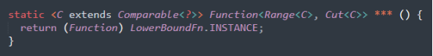

Which method name is better?

\*

|  |
| --- |
| lowerBoundFn |
| lowerBoundFunction |

Please kindly explain why the selected option should be preferred \*

\_\_\_\_\_\_\_\_\_\_\_\_\_\_\_\_\_\_\_\_\_\_\_\_\_\_\_\_\_\_\_\_\_

8.

Please read through the following code snippet where the original method name is marked by "\*\*\*". If necessary, you can refer to the enclosing class of the method at [this link](https://r.wjx.com/redirect.aspx?url=https%3A%2F%2Fgithub.com%2Fjiangyanjie%2FsurveyData%2Fblob%2Fmain%2FFirstRound%2F13%2F13.java&activity=267569930" \t "_blank). Among the names provided below, please indicate your preference for the method name.

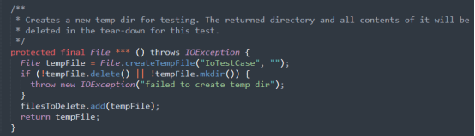 \*

|  |
| --- |
| createTempDir |
| createTemporaryDirectory |

Please kindly explain why the selected option should be preferred \*

\_\_\_\_\_\_\_\_\_\_\_\_\_\_\_\_\_\_\_\_\_\_\_\_\_\_\_\_\_\_\_\_\_

9.

Please read through the following code snippet where the original method name is marked by "\*\*\*". If necessary, you can refer to the enclosing class of the method at[this link](https://r.wjx.com/redirect.aspx?url=https%3A%2F%2Fgithub.com%2Fjiangyanjie%2FsurveyData%2Fblob%2Fmain%2FFirstRound%2F14%2F14.java&activity=267569930" \t "_blank). Among the names provided below, please indicate your preference for the method name.

 \*

|  |
| --- |
| numThreads |
| numberThreads |

Please kindly explain why the selected option should be preferred \*

\_\_\_\_\_\_\_\_\_\_\_\_\_\_\_\_\_\_\_\_\_\_\_\_\_\_\_\_\_\_\_\_\_

10.

Please read through the following code snippet where the original method name is marked by "\*\*\*". If necessary, you can refer to the enclosing class of the method at[this link](https://r.wjx.com/redirect.aspx?url=https%3A%2F%2Fgithub.com%2Fjiangyanjie%2FsurveyData%2Fblob%2Fmain%2FFirstRound%2F15%2F15.java&activity=267569930" \t "_blank). Among the names provided below, please indicate your preference for the method name.

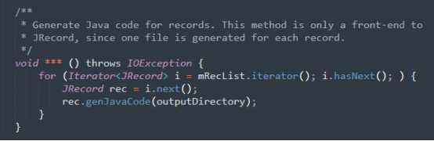 \*

|  |
| --- |
| genCode |
| generateCode |

Please kindly explain why the selected option should be preferred \*

\_\_\_\_\_\_\_\_\_\_\_\_\_\_\_\_\_\_\_\_\_\_\_\_\_\_\_\_\_\_\_\_\_

11.

Please read through the following code snippet where the original method name is marked by "\*\*\*". If necessary, you can refer to the enclosing class of the method at [this link](https://r.wjx.com/redirect.aspx?url=https%3A%2F%2Fgithub.com%2Fjiangyanjie%2FsurveyData%2Fblob%2Fmain%2FFirstRound%2F16%2F16.java&activity=267569930" \t "_blank). Among the names provided below, please indicate your preference for the method name.

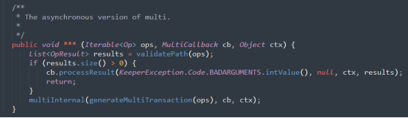 \*

|  |
| --- |
| multi |
| multiple |

Please kindly explain why the selected option should be preferred \*

\_\_\_\_\_\_\_\_\_\_\_\_\_\_\_\_\_\_\_\_\_\_\_\_\_\_\_\_\_\_\_\_\_

12.

Please read through the following code snippet where the original method name is marked by "\*\*\*". If necessary, you can refer to the enclosing class of the method at [this link](https://r.wjx.com/redirect.aspx?url=https%3A%2F%2Fgithub.com%2Fjiangyanjie%2FsurveyData%2Fblob%2Fmain%2FFirstRound%2F17%2F17.java&activity=267569930" \t "_blank). Among the names provided below, please indicate your preference for the method name.

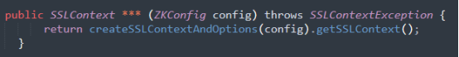 \*

|  |
| --- |
| createSSLContext |
| createSecureSocketsLayerContext |

Please kindly explain why the selected option should be preferred \*

\_\_\_\_\_\_\_\_\_\_\_\_\_\_\_\_\_\_\_\_\_\_\_\_\_\_\_\_\_\_\_\_\_

13.

Please read through the following code snippet where the original method name is marked by "\*\*\*". If necessary, you can refer to the enclosing class of the method at [this link](https://r.wjx.com/redirect.aspx?url=https%3A%2F%2Fgithub.com%2Fjiangyanjie%2FsurveyData%2Fblob%2Fmain%2FFirstRound%2F18%2F18.java&activity=267569930" \t "_blank). Among the names provided below, please indicate your preference for the method name.

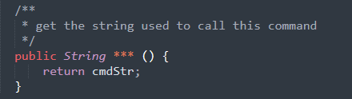 \*

|  |
| --- |
| getCmdStr |
| getCommandString |

Please kindly explain why the selected option should be preferred \*

\_\_\_\_\_\_\_\_\_\_\_\_\_\_\_\_\_\_\_\_\_\_\_\_\_\_\_\_\_\_\_\_\_

14.

Please read through the following code snippet where the original method name is marked by "\*\*\*". If necessary, you can refer to the enclosing class of the method at[this link](https://r.wjx.com/redirect.aspx?url=https%3A%2F%2Fgithub.com%2Fjiangyanjie%2FsurveyData%2Fblob%2Fmain%2FFirstRound%2F19%2F19.java&activity=267569930" \t "_blank). Among the names provided below, please indicate your preference for the method name.

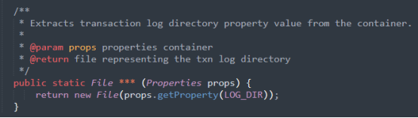 \*

|  |
| --- |
| getLogDir |
| getLogDirectory |

Please kindly explain why the selected option should be preferred \*

\_\_\_\_\_\_\_\_\_\_\_\_\_\_\_\_\_\_\_\_\_\_\_\_\_\_\_\_\_\_\_\_\_

15.

Please read through the following code snippet where the original method name is marked by "\*\*\*". If necessary, you can refer to the enclosing class of the method at [this link](https://r.wjx.com/redirect.aspx?url=https%3A%2F%2Fgithub.com%2Fjiangyanjie%2FsurveyData%2Fblob%2Fmain%2FFirstRound%2F20%2F20.java&activity=267569930" \t "_blank). Among the names provided below, please indicate your preference for the method name.

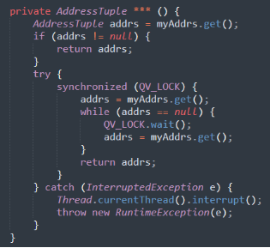 \*

|  |
| --- |
| getAddrs |
| getAddresses |

Please kindly explain why the selected option should be preferred \*

\_\_\_\_\_\_\_\_\_\_\_\_\_\_\_\_\_\_\_\_\_\_\_\_\_\_\_\_\_\_\_\_\_

16.

Please read through the following code snippet where the original method name is marked by "\*\*\*". If necessary, you can refer to the enclosing class of the method at[this link.](https://r.wjx.com/redirect.aspx?url=https%3A%2F%2Fgithub.com%2Fjiangyanjie%2FsurveyData%2Fblob%2Fmain%2FFirstRound%2F5%2F5.java&activity=267569930" \t "_blank) Among the names provided below, please indicate your preference for the method name.

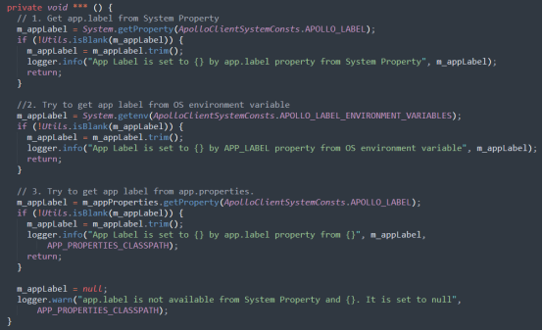 \*

|  |
| --- |
| initAppLabel |
| initializeApplicationLabel |

Please kindly explain why the selected option should be preferred \*

\_\_\_\_\_\_\_\_\_\_\_\_\_\_\_\_\_\_\_\_\_\_\_\_\_\_\_\_\_\_\_\_\_

17.

Please read through the following code snippet where the original method name is marked by "\*\*\*". If necessary, you can refer to the enclosing class of the method at [this link](https://r.wjx.com/redirect.aspx?url=https%3A%2F%2Fgithub.com%2Fjiangyanjie%2FsurveyData%2Fblob%2Fmain%2FFirstRound%2F6%2F6.java&activity=267569930" \t "_blank). Among the names provided below, please indicate your preference for the method name.

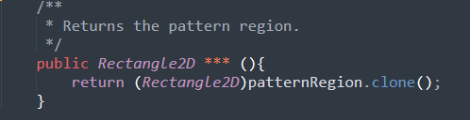 \*

|  |
| --- |
| getPatternRect |
| getPatternRectangle |

Please kindly explain why the selected option should be preferred \*

\_\_\_\_\_\_\_\_\_\_\_\_\_\_\_\_\_\_\_\_\_\_\_\_\_\_\_\_\_\_\_\_\_

18.

Please read through the following code snippet where the original method name is marked by "\*\*\*". If necessary, you can refer to the enclosing class of the method at [this link](https://r.wjx.com/redirect.aspx?url=https%3A%2F%2Fgithub.com%2Fjiangyanjie%2FsurveyData%2Fblob%2Fmain%2FFirstRound%2F7%2F7.java&activity=267569930" \t "_blank). Among the names provided below, please indicate your preference for the method name.

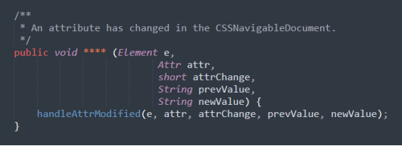 \*

|  |
| --- |
| attrModified |
| attributeModified |

Please kindly explain why the selected option should be preferred \*

\_\_\_\_\_\_\_\_\_\_\_\_\_\_\_\_\_\_\_\_\_\_\_\_\_\_\_\_\_\_\_\_\_

19.

Please read through the following code snippet where the original method name is marked by "\*\*\*". If necessary, you can refer to the enclosing class of the method at [this link](https://r.wjx.com/redirect.aspx?url=https%3A%2F%2Fgithub.com%2Fjiangyanjie%2FsurveyData%2Fblob%2Fmain%2FFirstRound%2F8%2F8.java&activity=267569930" \t "_blank). Among the names provided below, please indicate your preference for the method name.

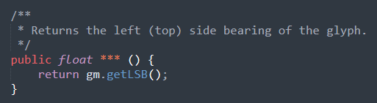 \*

|  |
| --- |
| getLSB |
| getLeftSideBearing |

Please kindly explain why the selected option should be preferred \*

\_\_\_\_\_\_\_\_\_\_\_\_\_\_\_\_\_\_\_\_\_\_\_\_\_\_\_\_\_\_\_\_\_

20.

Please read through the following code snippet where the original method name is marked by "\*\*\*". If necessary, you can refer to the enclosing class of the method at [this link](https://r.wjx.com/redirect.aspx?url=https%3A%2F%2Fgithub.com%2Fjiangyanjie%2FsurveyData%2Fblob%2Fmain%2FFirstRound%2F9%2F9.java&activity=267569930" \t "_blank). Among the names provided below, please indicate your preference for the method name.

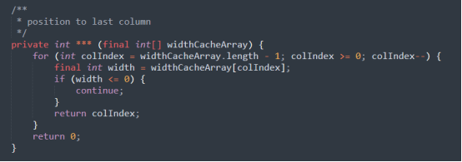 \*

|  |
| --- |
| indexLastCol |
| indexLastColumn |

Please kindly explain why the selected option should be preferred \*

\_\_\_\_\_\_\_\_\_\_\_\_\_\_\_\_\_\_\_\_\_\_\_\_\_\_\_\_\_\_\_\_\_